HW2

COE 546

Solution:

ISP 5%

show ip route

R8 10%

show ip route eigrp

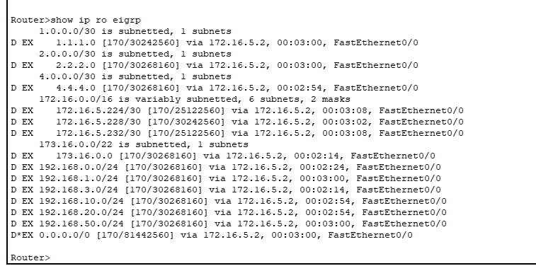

R5 20%

show ip route eigrp

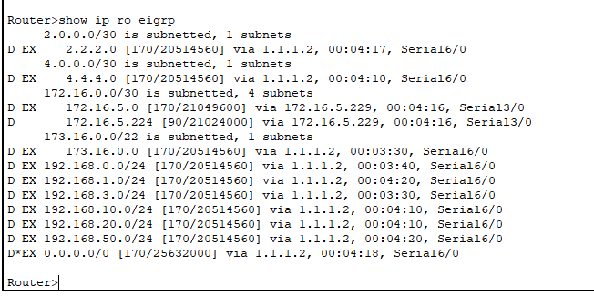

show ip eigrp topology

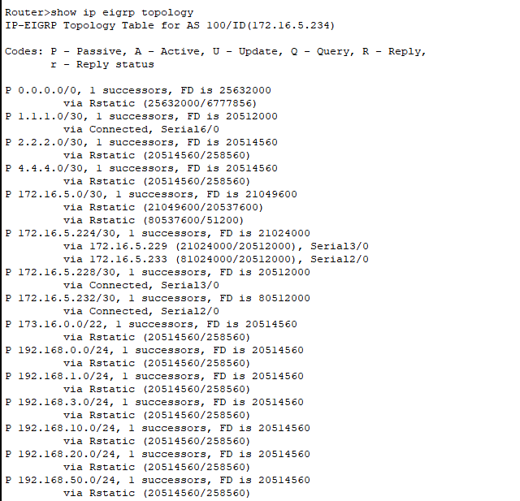

ASBR1 20%

show ip route

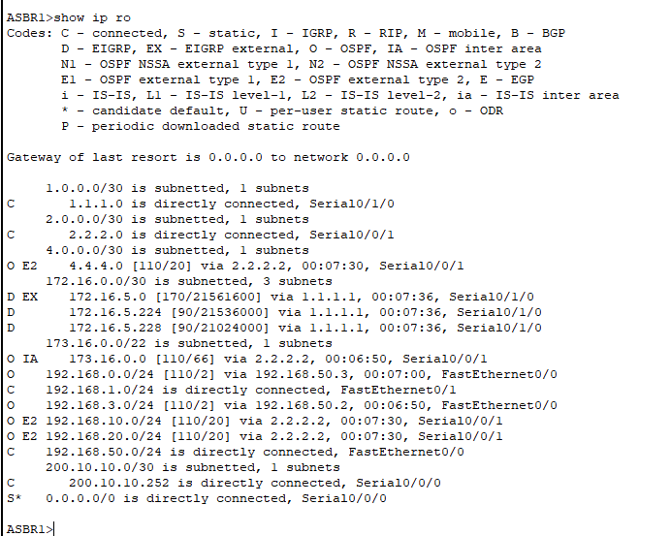

ASBR2/ABR1 10%

show ip route

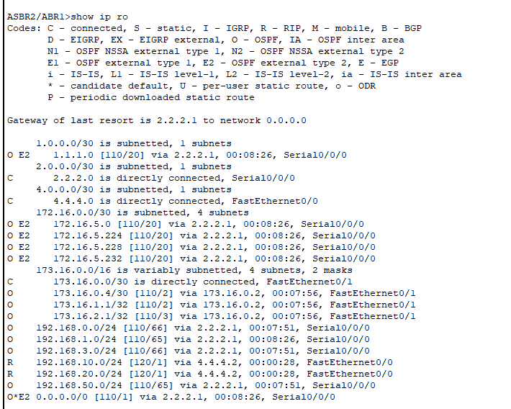

R2 10%

Show ip route ospf

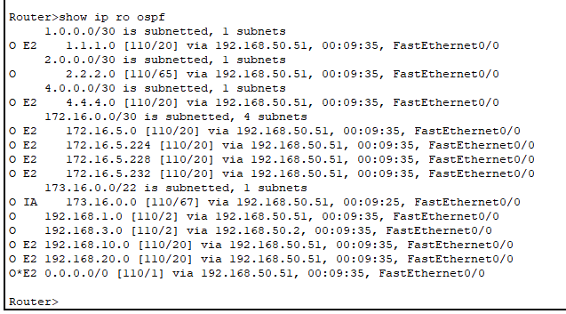

show ip ospf neighbor

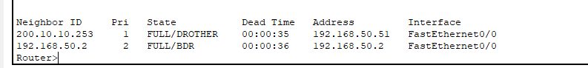

R10 5%

show ip route ospf

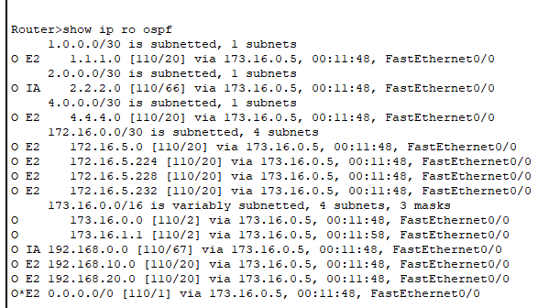

R4 10%

show ip route rip

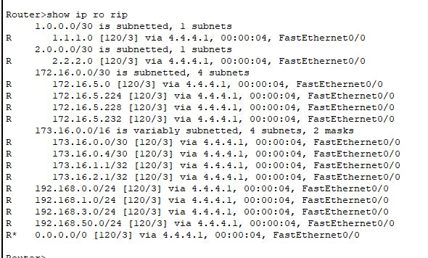

**For the following, please show the configuration of the first 4 ports only:**

Show ports configuration and Primary/Secondary RB for SW 7 2.5%

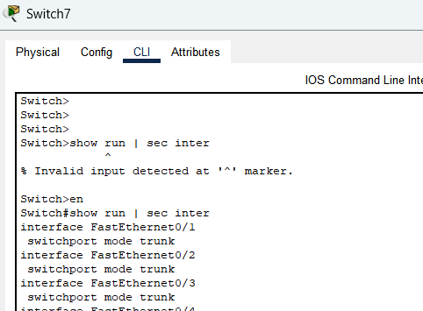

Vlan 10

Vlan 20

Show ports configuration and Primary/Secondary RB for SW10 2.5%

Vlan 10

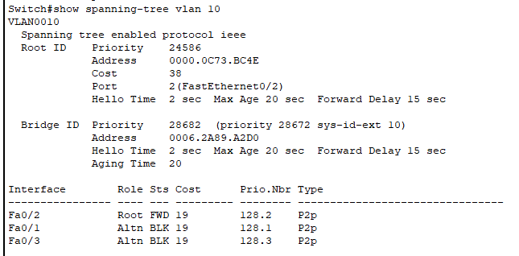

Vlan 20

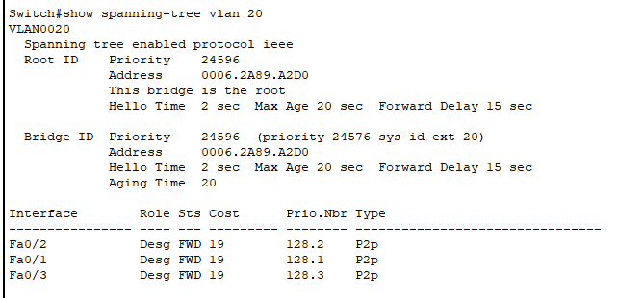

Show ports configuration for SW 8 2.5%

Show ports configuration for SW 9 2.5%

